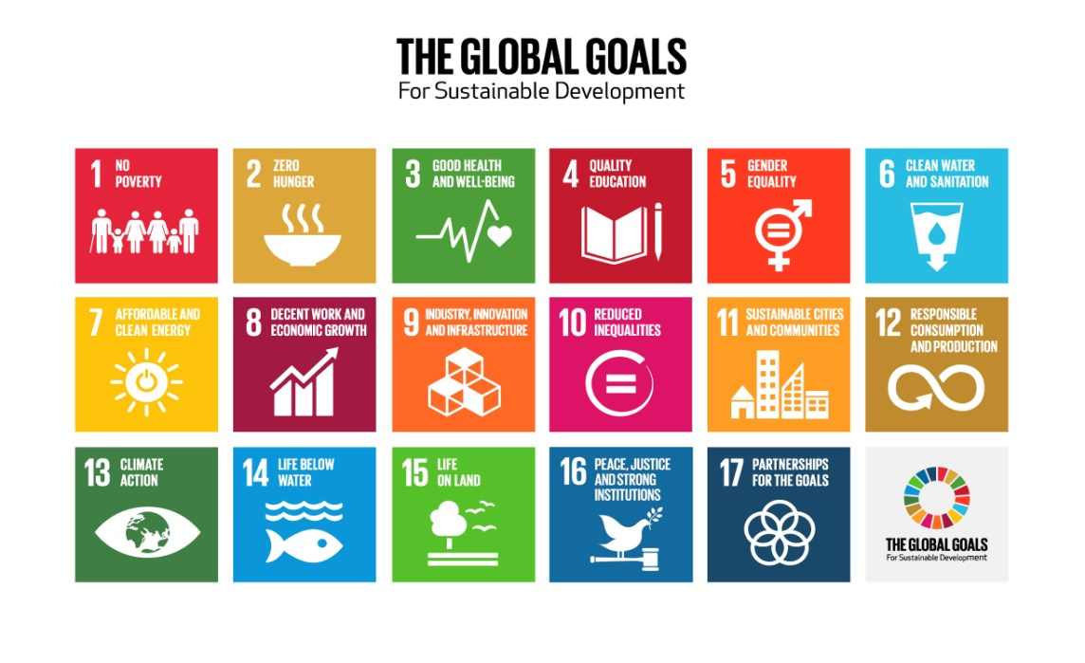

To make sure everyone has enough money to live on
To make sure everyone has enough food to eat
To make sure everyone is healthy
To make sure everyone has access to good education throughout their lives
To make sure men and women have equal opportunities
To make sure everyone has access to clean water and cleaning facilities
To make sure everyone has access to affordable energy from a sustainable source, e.g. solar energy
To make sure everyone can get a good job with fair pay and the economy grows
To provide good infrastructure (e.g. transport networks) and encourage new ideas in industry
To make sure everyone has equal opportunities, regardless of their age, race, religion or where they live
To make cities and communities safe, sustainable places to live in
To make sure things are produced and used efficiently
To try and reverse the negative impact human action has had on the climate
To protect natural environments and endangered species
To make sure we use the seas sustainably, e.g. avoid overfishing
To create a peaceful world where everyone has access to fair justice
To encourage countries, corporations and communities to work together towards the SDGs

